Sd cfvsdbfvmmv…-.ö,.lkk,mööö

OPOP spol. s r.o. õ………,
Zašovská 750, 757 01 Valašské Meziříčí
Tel.: 571 675 589, fax: 571 611 225

Z 100 BATCH STOVE

Content

A) Technical Description
B) Parameters of the Batch Stove
C) Transport
D) Installation of the Equipment
E) Commissioning
F) Maintenance of the Batch Stove
G) Waste Disposal
H) Warranty Sheet

A) Technical Description

The Z 100 batch stove is designed for DHW heating through combustion of solid fuels, i.e. coal, wood.
The stove is intended for local heating of warm utility water at sites where DHW heating is not regularly used and/or there is no other energy supply such as power or gas supply.

The solid fuel batch stove consists of an upper and lower part and a mixing battery which is not included in the package and must be purchased separately.

The upper part of Z 100 consists of an enclosed vessel and an internal tube. The vessel is designed as a pressure tank and works with pressure up to 6-8 Bars. The volume of the vessel is 95 l.
The stove must be operated in accordance with the present manual. Adult persons familiar with the present manual only may operate the stove, and it is imperative that children are kept out of the stove while in operation.

B) Parameters of the Batch Stove
Nominal power 8.0 kW
Water volume 95 dm3
Height 1500mm
Diameter of the upper part of the stove 370 mm
Diameter of the lower part of the stove 376 mm
Diameter of the smoke barrel 95 mm
Entry water connection external thread G 1/2“
Mixing batter spacing 100 mm
Ash tank volume 4 dm3
Min. chimney draught 10 Pa
Heating surface 1.1m2

C) Transport
The upper and lower parts of the stove are packed separately. The transport of the upper and lower part must only be done in the packaging specified and supplied by the manufacturer. When handled, the equipment must not be exposed to any mechanical loading such as impacts or hits against the external packaging and/or the external side of the packaging.
The position shown on the packaging is specified for transport of the upper part of the stove. In transport, the packaging must be secured against upsetting. During the transport, the packaging of the upper part of the stove may be stacked on one another to up to 3 layers.
Vertical position as shown in the packaging is specified for transport of the lower part of the stove.
Placing the packages holding the lower part of the stove on one another in transport is only permitted in the vertical position and provided that the packages are duly secured against upsetting. Maximum 3 pieces of the lower part of the stove may be stacked on one another.
CAUTION!
The stove parts must not be handled in the following way:
- handled in any way in the event of the damage of the packaging
- rolled, thrown, or caused to clash with other parts of the stove
- stacked on one another when transported otherwise than as specified by the manufacturer
- the manufacturer cannot be held accountable for any damage of the product during transport

D) Installation of the Equipment
- Positioning of the Stove
The connection of the batch stove to the chimney must be done with an approval of the chimney sweeping organisation in charge.
The stove must be installed to ČSN 73 4201 (workmanship of chimneys and smoke fuels and connecting fuel appliances to chimneys). The stove must be connected to the venting unit, with sufficient draught for all practically possible operating ratios. The piping circuit fitted in the chimney flue and slipped over the smoke barrel of the fuel appliance must be firmly assembled and fitted so that it does not get accidentally or spontaneously loose. The individual pipes of the smoke flue should be pushed at least 80mm into one another. Preferably, the smoke flue leading from the stove to the chimney will not be longer than 1m and will rise towards the chimney (approx. 1:20).
WARNING!
The stove and the smoke flue must be installed to ČSN 06 1008 in a safe distance of 200 mm from any flammable substances displaying degree B, C1 and C2 of flammability.
The degree of flammability of structural materials and products from the point of view of fire safety shall be determined ČSN 73 0823.
The above safe distance of 200 mm must be doubled if the fuel appliances and smoke flues are located in the vicinity of flammable materials displaying the degree C3 of flammability. The safe distance must be doubled even if the degree of flammability of the flammable substance is not known.
The safe distance may be reduced to its half if a heat insulating shielding plate at the thickness of at least 5mm, located 25cm from the protected flammable substance is used (air insulation) .

Division of Substances into Degrees of Flammability (see ČSN 73 0823).
A) non-flammable: stone, granite, sand stone, concrete mixes, porous concrete, foam concrete, bricks, fireclay, mortars, plastering, metals, glass and other mineral melts, asbestos-cement plates
B) hardly flammable: Acumine, Izomine, plasterboard plates, Heraclites, Lignos, Rayolite, Velox, novodur, Durufol B, Duroplast H, Dekorplast, Rotizol, basalt felt, Haver, glass-fibre mat
C1) flammable with difficulty: hard timber, beech, oak, plywood, Hobrex, Sirkolit, Werzalit, Ecrona, Umakart
C2) medium flammable: white-sawn timber, pine, larch, spruce, chipboard plates, Piloplat, Duplex, Solodur, cork plates SP, cork parquet
C3) easily flammable: laminated chipboard plates, sawdust boards, Pilolamite, fibreboard, hardboard, Sololak, Sololite, BA cork boards, Polystyrene, Polyurethane
The stove may be used to ČSN 33 20 00 - 3:1995 in the basic AA5/AB5 environment.
The stove must not be used if there is a temporary risk of emergence of flammable gases or vapours in the vicinity (such as when gluing lino flooring, PVC, etc.) The stove must be decommissioned in time.
If the floor is made out of flammable material, the stove must be based on a non flammable heat insulated padding that will exceed the stove on the side of the hatch by approx. 30 cm and by at least 10 cm on the other sides.
No flammable objects may be placed on the appliance and within distances smaller than that identified as the safe distance.
In order to fill the gap between the two parts, you may use fireclay, which may be produced by mixing chamotte flour with water (the flour is added in the sachets in the package containing the lower part of the stove).
Form a thick porridge by stirring and apply a sufficient quantity of the porridge to the external bearing ring of the lower part. Then, fit the upper part, check the degree to which the gap is filled between the two parts by the chamotte mortar (clay). The as filled gap shall then be left to stiffen up. Before the stove is put into use to the nominal power, it is necessary that the chamotte sealing is burnt out, see the chapter on putting the stove into operation. If the two parts are not sealed in this way, the false air may cause overheating of all parts of the stove and destroy the sealing.

2 Fitting the Mixing Battery

Mixing battery which is not included in the package and must be purchased separately. Connecting diameters of the battery inlets is 10cm, with G 1/2“ external thread outlets.

3 Connection to Water Piping

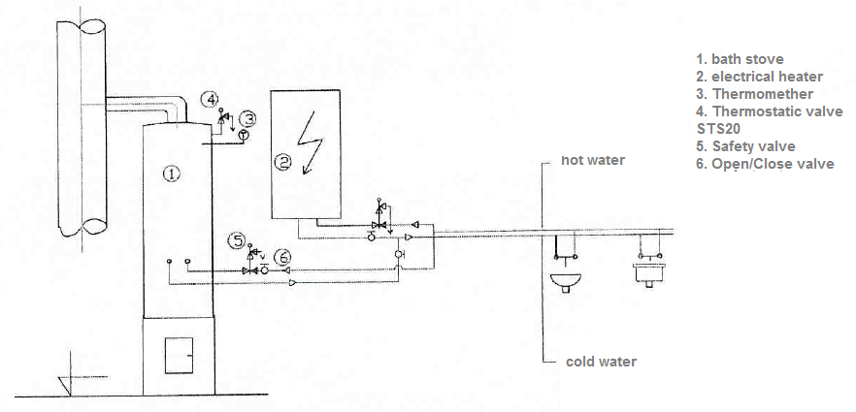

E) Commissioning
WARNING!
The appliance (stove) may only be operated by adults.

With the initial commissioning it is necessary (before operating the stove to its nominal heating capacity) to burn the fireclay sealing so that any damage of the fireclay lining through overheating could be prevented. In order to make this happen, the stove must be heated twice or three times by lightly burning wood.

When heating up the stove, an increased volume of combusting air needs to be provided during a shorter period of time. This may be accomplished by slightly opening the hatch. With the stove being operated to the nominal power, the combusting air may be regulated by the above air control feature on the stove hatch. Removing ash from the grate in operation may be done with the hatch closed from outside using a control bar. The bar is controlled via the bakelite ball located at the end of the bar; the metallic part of the control bar is heated in operation – risk of burning injuries.
WARNING!
Overheating the water in the stove needs to be prevented so that increased formation of scale induced by the process is avoided.

Maintenance of the Batch Stove

When cold, the outside surfaces of the stove need to be wiped with a cloth soaked in a hot soap solution, then wiped again with a wet cloth and polished with a dry cloth. It needs to be made sure that ash remnants do not accumulated in the space left for the ash drawer as they could potential fall outside the ash drawer and prevent it from being slid properly in.

The ash must be disposed of into a non flammable vessel with a lid.

G) Waste Disposal

The packaging material (paper) may be burned in the stove, the PP tape, non burned remnants and ash needs to be disposed of as household waste.
Following the expiry of the service life of the stove, the shell and grates shall be disposed of as metallic scrap, the fireclay bricks shall be handed over at a collecting yard.

WARRANTY SHEET
Upper stove part fabrication no. *
Lower stove part fabrication no. *

Volume of the Tank: 95 l
Power: 8 kW
Fabricator: OPOP spol. s r.o., Valašské Meziříčí
Tel.: 571 675 589, fax: 571 611 225
Shipped from plant:
Warranty Conditions:
The present warranty sheet contains a certificate of quality and completeness. The manufacturer declares that the product is controlled and meets, through its workmanship, the technical conditions and ČSN 06 12 01 and ČSN 06 1215.
We guarantee for the quality, function, and workmanship of the stove for 24 months of the date of sale to the relevant customer, not later however, than within 30 months of shipping the stove from the production plant, namely by undertaking to remove any defects demonstrably caused by defective material, faulty construction or faulty workmanship within the shortest possible deadline, at our expense provided that the batch stove:
- is in the ordinary technical condition according to the operating manual
- is connected to a vent stack according to ČSN 73 4201
- have not been mechanically damaged by force (no unauthorised interventions have been made save for those permitted in the operating manual)
- the chimney draught to ČSN is equal to 10 Pa (1.0 mm of water column)
- the customer, when enforcing their complaint, submitted the present Warranty Sheet, duly completed
- manufacturer’s instructions for the installation and use given in the manual have been complied with
- the warranty does not the sealing material (sealing rings)
- if the inlet water pressure to the stove is up to100 kPa, max.
- in the event of a claim against the upper part, complete the fabrication number of the claimed upper part in the warranty sheet

TK on________________________ Sold on ______________________*
* Data to be filled in at the sale of the batch stove

