OPOP spol. s r.o.
Zašovská 750, 757 01 Valašské Meziříčí
Tel.: 571 675 589, fax: 571 611 225

LK 100 BATCH STOVE

Contents

A) Technical Description
B) Parameters of the Batch Stove
C) Transport
D) Installation of the Equipment
E) Commissioning
F) Water Supply and Discharge of the Stove
G) Maintenance of the Batch Stove
H) List of Replaceable Spare Parts
I) List of Accessories Supplied
J) List of Optional Accessories
K) Waste Disposal
L) Warranty Sheet

A) Technical Description

The LK 100 batch stove is designed for TUV heating through combustion of solid fuels, i.e. soft coal, wood.
The stove is intended for local heating of warm utility water at sites where TUV heating is not regularly used and/or there is no other energy supply such as power or gas supply.
WARNINIG!
The batch stove is a pressure-free vessel, therefore, it is absolutely crucial that the entry water flow pressure be set to max. 100 kPa (the reduction valve is included in the product package).

The solid fuel batch stove consists of an upper and lower part and a mixing battery.

The upper part of LK 100 consists of an enclosed vessel manufactured of steel sheeting and an internal tube. The internal part of the vessel has surfaces have non corroding treatments. The vessel is designed as a pressure free tank and works to the overflow principle. The volume of the vessel is 95 l. The bottom part of the vessel has on welded two on-welded 1/4“ sleeves to allow the proper positioning of the discharge valve. The other hole will be sealed with a G1/4” seal.
A mixing battery with a sprinkler has been installed in the middle part of the vessel. An overflow pipe located inside the vessel is connected to the mixing battery. The connection between the overflow pipe and the mixing battery is permanently opened. When the cold water battery valve is opened, cold water flows directly from the supply, via a sprinkler hose and/or a discharge tube attached to the mixing battery. When the hot water valve is opened, the cold water flows into the vessel and forces hot water up, with the latter flowing via an overflow pipe into the mixing battery where it is mixed with cold water (if the cold water valve is opened). There is a sprinkler switch installed at the battery outlet. Using this switch, water discharge may be regulated either via a sprinkler or via an arm into the tube.
The lower part of LK 100 consists of a surface treated steel sheeting shell. The fireplace consists of alloy fixed grate. Inside the grate, there is moving round grate which is tow bar controlled. The walls of the fireplace are provided with fire-clay lining. The fireplace is designed for heating with solid fuels. He common hatch for the fireplace and the ash tank are sealed with a heat insulating rope. The hatch has a fixed facility for the control of the combusting air. Under the grate, there is an ash space fitted with an ash sector.
Important:
The stove must be operated in accordance with the present manual. Adult persons familiar with the present manual only may operate the stove, and it is imperative that children are kept out of the stove while in operation.

B) Parameters of the Batch Stove
Nominal power 8.0 kW
Water volume 95 dm3
Height 1500mm
Diameter of the upper part of the stove 370 mm
Diameter of the lower part of the stove 376 mm
Diameter of the smoke barrel 95 mm
Entry water connection external thread G 1/2“
Mixing batter spacing 35 mm
Ash tank volume 4 dm3
Min. chimney draught 10 Pa
Heating surface 1.1m2
Upper part weight 25 kg
Lower part weight 30 kg
Total stove weight 55 kg

C) Transport
The upper and lower parts of the stove are packed separately. The transport of the upper and lower part must only be done in the packaging specified and supplied by the manufacturer. When handled, the equipment must not be exposed to any mechanical loading such as impacts or hits against the external packaging and/or the external side of the packaging.
The position shown on the packaging is specified for transport of the upper part of the stove. In transport, the packaging must be secured against upsetting. During the transport, the packaging of the upper part of the stove may be stacked on one another to up to 3 layers.
Vertical position as shown in the packaging is specified for transport of the lower part of the stove.
Placing the packages holding the lower part of the stove on one another in transport is only permitted in the vertical position and provided that the packages are duly secured against upsetting. Maximum 3 pieces of the lower part of the stove may be stacked on one another.
CAUTION!
The stove parts must not be handled in the following way:
- handled in any way in the event of the damage of the packaging
- rolled, thrown, or caused to clash with other parts of the stove
- stacked on one another when transported otherwise than as specified by the manufacturer
- the manufacturer cannot be held accountable for any damage of the product during transport

D) Installation of the Equipment
- Positioning of the Stove
WARNING!
The connection of the batch stove to the chimney must be done with an approval of the chimney sweeping organisation in charge.
The stove must be installed to ČSN 73 4201 (workmanship of chimneys and smoke fuels and connecting fuel appliances to chimneys). The stove must be connected to the venting unit, with sufficient draught for all practically possible operating ratios. The piping circuit fitted in the chimney flue and slipped over the smoke barrel of the fuel appliance must be firmly assembled and fitted so that it does not get accidentally or spontaneously loose. The individual pipes of the smoke flue should be pushed at least 80mm into one another. Preferably, the smoke flue leading from the stove to the chimney will not be longer than 1m and will rise towards the chimney (approx. 1:20).
WARNING!
The stove and the smoke flue must be installed to ČSN 06 1008 in a safe distance of 200 mm from any flammable substances displaying degree B, C1 and C2 of flammability.
The degree of flammability of structural materials and products from the point of view of fire safety shall be determined ČSN 73 0823.
The above safe distance of 200 mm must be doubled if the fuel appliances and smoke flues are located in the vicinity of flammable materials displaying the degree C3 of flammability. The safe distance must be doubled even if the degree of flammability of the flammable substance is not known.
The safe distance may be reduced to its half if a heat insulating shielding plate at the thickness of at least 5mm, located 25cm from the protected flammable substance is used (air insulation) .

(Horní/spodní část kamen – Upper/lower part of the stove; ruční sprcha – hand sprinkler; sprchová hadice – sprinkler hose; mísící baterie – mixing battery; výpustný ventil – discharge valve; zátka – seal; rám dvířek – hatch frame; přikládací dvářka – stoking door; uzávěr dvířek – door closure; váčko prim. vzduchu – Primary (??) air cap; popelník – ash pan; rošt kruhový – round grate; ovládací tyč roštu – Grate control bar; šamotové tvarovky – fireclay bricks; přívod vody – Water supply; anodová tyč – anode bar; přepadová trubka – overflow pipe; odvod spalin – flue gas exhaust

Division of Substances into Degrees of Flammability (see ČSN 73 0823).
A) non-flammable: stone, granite, sand stone, concrete mixes, porous concrete, foam concrete, bricks, fireclay, mortars, plastering, metals, glass and other mineral melts, asbestos-cement plates
B) hardly flammable: Acumine, Izomine, plasterboard plates, Heraclites, Lignos, Rayolite, Velox, novodur, Durufol B, Duroplast H, Dekorplast, Rotizol, basalt felt, Haver, glass-fibre mat
C1) flammable with difficulty: hard timber, beech, oak, plywood, Hobrex, Sirkolit, Werzalit, Ecrona, Umakart
C2) medium flammable: white-sawn timber, pine, larch, spruce, chipboard plates, Piloplat, Duplex, Solodur, cork plates SP, cork parquet
C3) easily flammable: laminated chipboard plates, sawdust boards, Pilolamite, fibreboard, hardboard, Sololak, Sololite, BA cork boards, Polystyrene, Polyurethane
The stove may be used to ČSN 33 20 00 - 3:1995 in the basic AA5/AB5 environment.
The stove must not be used if there is a temporary risk of emergence of flammable gases or vapours in the vicinity (such as when gluing lino flooring, PVC, etc.) The stove must be decommissioned in time.
If the floor is made out of flammable material, the stove must be based on a non flammable heat insulated padding that will exceed the stove on the side of the hatch by approx. 30 cm and by at least 10 cm on the other sides.
No flammable objects may be placed on the appliance and within distances smaller than that identified as the safe distance.
In order to fill the gap between the two parts, you may use fireclay, which may be produced by mixing chamotte flour with water (the flour is added in the sachets in the package containing the lower part of the stove).
Form a thick porridge by stirring and apply a sufficient quantity of the porridge to the external bearing ring of the lower part. Then, fit the upper part, check the degree to which the gap is filled between the two parts by the chamotte mortar (clay). The as filled gap shall then be left to stiffen up. Before the stove is put into use to the nominal power, it is necessary that the chamotte sealing is burnt out, see the chapter on putting the stove into operation. If the two parts are not sealed in this way, the false air may cause overheating of all parts of the stove and destroy the sealing.

The G ¼” sealing cap and the discharge valve are interchangeable depending on the local installation conditions. The two parts need to be screwed onto the threaded flanges in a waterproof fashion.

2 Fitting the Mixing Battery

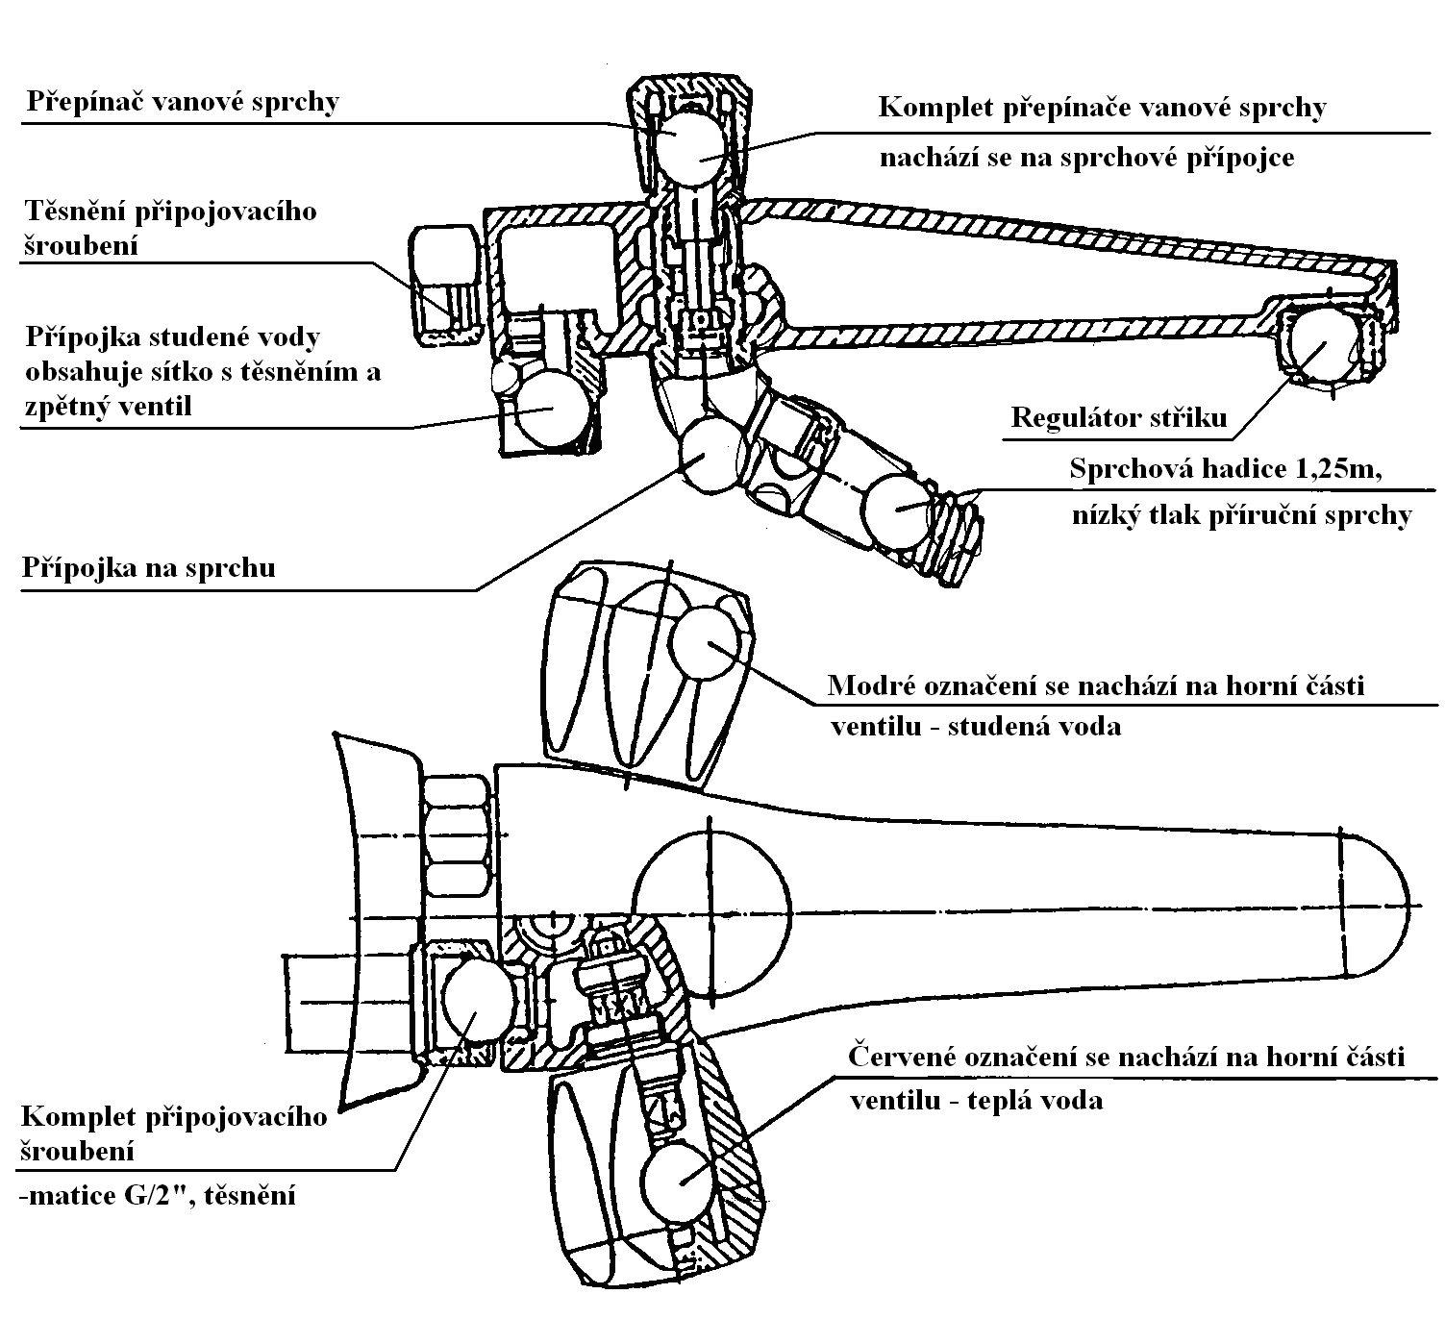
Přepínač vanové sprchy – Tube sprinkler switch; těsnění připojovacího šroubení – sealing of connecting bolting; přípojka studené vody obsahuje sítko s těsněním a zpětný ventil – the cold water connection contains a sieve with a sealing and a reverse valve; přípojka na sprchu – sprinkler connection; komplet připojovacího šroubení – connection bolting assembly; matice G/2”, těsnění – G/2” nut, sealing; komplet přepánače vanové sprchy - Tube sprinkler switch assembly – nachází se na sprchové přípojce - located on the sprinkler connection; regulator stříku – sprinkling controller; sprchová hadice – sprinkler hose; modré označení se nachází na horní části ventilu … – the blue designation is located on the upper part of the valve – cold water; červené označení se nachází na … - the red designation is located on the upper part of the valve – hot water; nízký tlak příruční sprchy – low hand sprinkler pressure

The battery’s body is fitted in the back part over 2 sleeve nuts to the batch stove vessel. The water supply into the batch stove is mouthed in the lower part of the battery body.

Important:

Only a manufacturer designated battery may be fitted to the upper part of LK100.
Another type of battery or connection other than that given in the manual for operating the product may lead to damage of the upper part through overpressure.

Any complaints will be deemed unwarranted.

3 Connection to Water Piping
WARNING!
The connection of the bathroom stove must be done to the requirements given in this manual. At the same time, the admissible water pressure of max. 100 kPa must be provided. This water pressure adjustment may in principle be made prior to the mixing battery.
The specified pressure may be provided with the use of a reducing valve with the required value. We recommend installing a reverse valve in the water supply.
Failure to comply with the present regulation may lead to destruction of the cylinder of the bathroom stove. When assembling the connection to the water supply pipeline it is unconditionally required that the following regulations be adhered to:

- it is necessary that a closing valve be fitted into the water supply line upstream of the stove so that the supply line could be instantaneously choked in the event of any assemblies, discharging, risk of frost or in the event of damage without having to close the entire water supply line in the house
- the seals attached must be used for sealing

In order to connect the bathroom stove to the water supply line, no mechanical strains may remain in the connection.
The sprinkler hose must not be scrolled around, broken or tensile loaded in use.

E) Commissioning
WARNING!
The appliance (stove) may only be operated by adults.

Before each heating, fill the upper part fully with water. This shall be done by opening the hot water valve. If any water starts to flow in trough the discharge arm and/or the sprinkler hose, the upper vessel has been filled. The hot water valve may be closed.

WARNING!
With the initial commissioning it is necessary (before operating the stove to its nominal heating capacity) to burn the fireclay sealing so that any damage of the fireclay lining through overheating could be prevented. In order to make this happen, the stove must be heated twice or three times by lightly burning wood.

When heating up the stove, an increased volume of combusting air needs to be provided during a shorter period of time. This may be accomplished by slightly opening the hatch. With the stove being operated to the nominal power, the combusting air may be regulated by the above air control feature on the stove hatch. Removing ash from the grate in operation may be done with the hatch closed from outside using a control bar. The bar is controlled via the bakelite ball located at the end of the bar; the metallic part of the control bar is heated in operation – risk of burning injuries.
WARNING!
Overheating the water in the stove needs to be prevented so that increased formation of scale induced by the process is avoided.
WARNING!
When heating the stove up, the volume of water in the vessel starts to grow with the growing temperature. The growth of volume of heated water will not be reflected by an increase pressure in the vessel, but rather by water dripping from the discharge arm and/or from the sprinkler as the overflow pipe is still open to the discharge via the mixing battery.
The dripping from the sprinkler during water heating in the vessel is necessary.

- Water Supply and Discharge of the Stove

The water is withdrawn by the mixing battery (as described in the technical description). When emptying the stove, the closing valve in the water supply system of the batch stove closes and the discharging valve located in the lower part of the vessel is loosened. In order to prevent the emergence of underpressure in the vessel and achieve faster vessel emptying, loose the 1" seal located in the upper part of the vessel.

Maintenance of the Batch Stove
WARNING! In the event of a risk of freezing, the bathroom stove must be emptied.
At least once a year, it is necessary that the sieve in the discharge arm at the battery and the overflow pipe be blown though to check whether they are stuffed with scale, or cleaned or replaced.
When cold, the outside surfaces of the stove need to be wiped with a cloth soaked in a hot soap solution, then wiped again with a wet cloth and polished with a dry cloth. It needs to be made sure that ash remnants do not accumulated in the space left for the ash drawer as they could potential fall outside the ash drawer and prevent it from being slid properly in.

WARNING!!! The ash must be disposed of into a non flammable vessel with a lid.

H) List of Replaceable Spare Parts
- Upper stove part
Name of part Ordering no.
Upper part – vessel LK H001
G ¼”Discharge valve LK H002
F ¼” seal LK H003
G 1” seal LK H004
Overflow pipe LK H005
2. Mixing battery
Battery body LK B001
Sprinkler hose LK B004
Hand sprinkler LK B005
3. Lower stove part
Lower stove part LK S001
Complete hatch LK S002
Round basket – alloy LK S003
Round grate – alloy LK S004
Shaped fireclay brick LK S005
Grate control bar LK S006
Ash pan LK S007

I) Included as separately supplied accessories are
Upper part – the complete vessel in a separate packaging
G ¼” seal, G ¼” discharge valve, G 1” seal
Warranty Sheet
Upper part of the stove in a separate packaging, the following items are included in the packaging:
- ash pan – a bag containing the chamotte flour
- operating manual including the warranty sheet
Mixing battery – sprinkler hose, hand sprinkler, cover
Reducing valve ½“, set the outlet pressure to 100 kPa

J) List of Optional Accessories of the Stove
- Closing valve with a reverse ½” valve
½” insert

K) Waste Disposal
The packaging material (paper) may be burned in the stove, the PP tape, non burned remnants and ash needs to be disposed of as household waste.
Following the expiry of the service life of the stove, the shell and grates shall be disposed of as metallic scrap, the fireclay bricks shall be handed over at a collecting yard.

WARRANTY SHEET
for LK 100 Batch Stove
Upper stove part fabrication no. *
Lower stove part fabrication no. *

Volume of the Tank: 95 l
Power: 8 kW
Fabricator: OPOP spol. s r.o., Valašské Meziříčí
Tel.: 571 675 589, fax: 571 611 225
Shipped from plant:
Warranty Conditions:
The present warranty sheet contains a certificate of quality and completeness. The manufacturer declares that the product is controlled and meets, through its workmanship, the technical conditions and ČSN 06 12 01 and ČSN 06 1215.
We guarantee for the quality, function, and workmanship of the stove for 24 months of the date of sale to the relevant customer, not later however, than within 30 months of shipping the stove from the production plant, namely by undertaking to remove any defects demonstrably caused by defective material, faulty construction or faulty workmanship within the shortest possible deadline, at our expense provided that the batch stove:
- is in the ordinary technical condition according to the operating manual
- is connected to a vent stack according to ČSN 73 4201
- have not been mechanically damaged by force (no unauthorised interventions have been made save for those permitted in the operating manual)
- the chimney draught to ČSN is equal to 10 Pa (1.0 mm of water column)
- the customer, when enforcing their complaint, submitted the present Warranty Sheet, duly completed
- manufacturer’s instructions for the installation and use given in the manual have been complied with
- the warranty does not the sealing material (sealing rings)
- if the inlet water pressure to the stove is up to100 kPa, max.
- in the event of a claim against the upper part, complete the fabrication number of the claimed upper part in the warranty sheet

TK on________________________ Sold on ______________________*
* Data to be filled in at the sale of the batch stove

Note:
When noting a defect, it is necessary to submit the present warranty sheet at all times, give the full address and mention the circumstances in which the defect occurred. Our company shall decide on the method and place of the repair.

Product Complaint Procedure:

- Submit a duly confirmed warranty sheet with a document attesting that you have paid for the product in person, by mail or fax.
- Report the full address and/or the telephone number and give an account of the circumstances, during which the defect occurred.
- The servicing engineer of the manufacturer shall note to the user of the product the method of dealing with the complaint.
a) Send the claimed part for replacement.
b) If the procedure given under point a) proves impossible, the manufacturer will be entitled to determine the method, deadline and execution of the repair by their servicing staff or staff of a contractual partner.
c) The user shall be obliged to make it possible for the manufacturer to proceed with the repair as set forth under point b)
d) If the user fails to allow the servicing staff access to the equipment to effectuate the repair, the manufacturer shall deem the entire complaint concluded.
e) If the defects proves irremovable, the user shall be entitled to have the defective part replaced. Yet, if the complaint is unjustified, i.e. if the defect is not confirmed by the servicing staff deployed, the complaining party will be charged the costs associated with the inspection and the travel.
f) Failure to indicate the fabrication number for any complaint against the upper part in the warranty sheet will render the complaint invalid.
g) If you need to speed up the complaint procedure, contact our servicing staff at the following telephone numbers: 571 675 252 or 602 743 970

Dear Customer,
We are very pleased that you have decided to obtain our product. This solution makes you fit for a 10% discount of the price of spare parts. I order to be able to use the above advantage, you need to fill in the registration card and send it to our address:
OPOP spol s r.o.
Obchodní oddělení
Zašovská 750
757 01 Valašské Meziříčí
Once we receive the completed for, we will send you your Customer Card by return. The Card will make eligible for discounted spare part prices applied by the manufacturer. When ordering spare parts, you need to present the Customer Card No. indicated therein.

Thank you for your trust.
Zde odstřihněte a zašlete na naši adresu
……………………………………………………………………………………

REGISTRAČNÍ KARTA

Jméno………………………….. výrobní číslo výrobku…………………….

Příjmení………………………… prodejce…………………………………..

Ulice a č.p. …………………….. typ výrobku……………………………….

Město……………………………

PSČ……………………………..

Telefonní číslo(nepovinné)…………………………

Podpis……………………………………………

